Un Cuento de Hadas
You and your partner will write a cuento de hadas (fairytale) correctly using the imperfect and preterite. Then you will make your written story into a short fairytale movie using PuppetPalsHD.
TURN IN:
ROUGDRAFT due ______________________: If you do not have a roughdraft on due date, your grade will drop one letter grade.
TYPED or NEAT HANDWRITTEN FINAL DRAFT due _____________________: highlight preterite in one color and imperfect in a different color. Make sure to provide a key for colors as well as a list of all new words in Spanish and English you used.
A MOVIE due _________________________: minimum of 3 minutes, no longer than 5 minutes created using PuppetPalsHD on iPad.
There are two options: 1) You can take an existing fairytale and adjust to the new millennium. OR 2) you can create a completely new up to date fairytale.
Be sure to include some elements that are typical for a fairytale: A little bit of magic, a curse, a task to fulfill, a secret, a difficult journey, animals/objects that talk, accomplished or unaccomplished dreams, a transformation to an animal/object, final solution, etc….
BRAINSTORM:
Choose up to 7 actors (you can bring them in/out of the scene when needed)
PERSONAJES (Characters)
squirrel – la ardilla
crow – el cuervo
dragon – el dragón
(bad/good) fairy – el hada* (mala/buena)
fairy godmother – el hada madrina*
knight – el caballero
prince (charming) – el príncipe (azul)
princess – la princesa
witch – la bruja

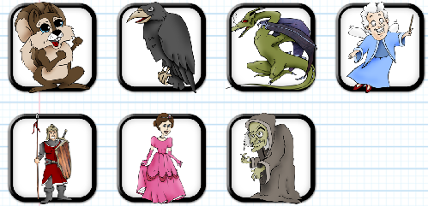
*Notes: Even though hada and hada madrina are feminine, you use “el” because you can't say "la hada" for the same reason you can't say "la agua" or "la águila" due to a difficulty in pronunciation when the noun starts with "a (ha)" and the accent goes in the first syllabus. When you make it plural, you can say “las”. Be sure the adjectives to describe them are feminine though!
Choose up to 3 backdrops (you can switch them during video)
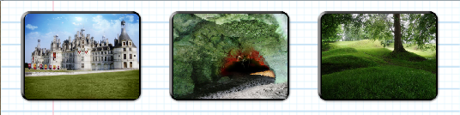
ESCENAS (Scenes)
castle - un castillo
cave - una cueva
forest – el bosque

Lista de control (checklist):
- Set the Scene: A clear introduction setting the scene/background, presentation of the main character(s)
- Create the Events: Development of the plot telling what happened and sudden changes
- Expand the Mental, Emotional State and Suspense: Extension of the mental, emotional and physical characteristics of the main character(s)
- Resolve: A creative ending that can be a final solution, an open ending, a mythical ending…..
- CREATIVE!

With your partner, jot down some elements you would like to include in your story.
____________________________________________________________________________________________________________________________________________________________________________________________________________________________________________________________________________________________________________________________________________________________________________________________________________________________________________________________________________________
Vocabulary List: Write any new words in Spanish/English you want to use in your story. Be sure to include this list on your final draft.
_________________________________________________________________________________________________________________________________________________________________________________________________________________________________________
Palabras útiles (Useful Words) – if you use one of these be sure to include on vocab list on final draft
evil/wicked: malo/malvado, kingdom: el reino, magic potion: una bebida mágica, magic wand: la varita mágica, magical: mágico, poison: el veneno, spell: un hechizo, sword: una espada, to cast a spell: poner un hechizo, to fall in love: enamorarse, to wish: desear, a wish: un deseo

You will be graded on the following:
Contenido (Contents)
- Has sufficient details and information
- The sentences are fluid and pronounced well in video
- It is well organized and interesting to read/watch

Gramática (Grammar)
- Verbs – correct tenses and verb conjugation
- Use of SER vs. ESTAR with descriptions/emotions
- Agreement – adjective/noun (gender and number), subject/verb

Mecánica (Mechanics)
- spelling □ accents

