Milagros: Miracles
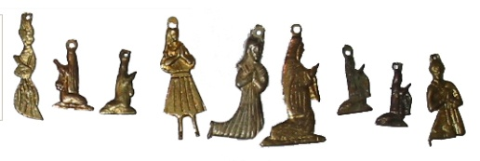

Milagro means miracle. Milagros (which are also called ex-votos) are tiny silver or gold shapes that are used as offerings, much like candles are used in Catholic churches. They are given symbolically to a saint by someone looking for a miracle. The person in need comes to church with a prayer or a request for assistance, or to give thanks for a prayer fulfilled. The worshipper then places or pins the milagro on the image of the saint in the church. Milagros are used in Peru, Mexico, and other parts of Latin America, as well as in parts of the United States, to offer prayers and wishes to the saints.

Traditional milagros are medals in the shape of body parts, animals, and people, but they can be of almost anything. In this activity we will use milagros to symbolize our desire for either how we want our future job to be, how we want our future love to be or what we want our family, friends and ourselves to do this summer.

Traditional Milagros shapes and meanings:

Heart = love
Hand = sharing or helping
Arm = strength or work
Foot = your journey
Head = wisdom
Fish = plentiful food
Eyes = someone who cares and who will watch over you

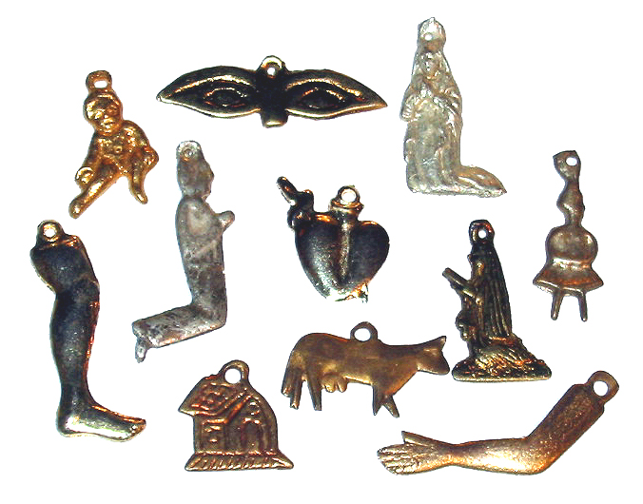
What you need:
Mechanical pencil
Pen
5 x 2 ½ piece of aluminum foil
2 ½ x 2 ½ piece of paper
Hole punch

What to think about:
Read the following 3 questions and choose which one you would like to write about and create a symbol for.
- ¿Cómo quiero que sea mi futura profesión?
- ¿Cómo deseo que sea mi futuro amor?
- ¿Qué espero que hagamos mi familia, mis amigos y yo este verano?

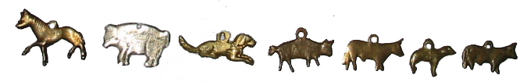

Writing:
You will write 3 sentences about the topic you chose to reflect on being sure not to repeat your indicator. Here are some indicator options:
Ojalá que
Deseo que
Quiero que
Espero que
Prefiero que
Also do not repeat your second verb (in the subjunctive). So don’t use the verb “ser” for example all 3 times, switch it up.
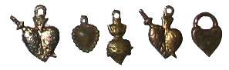
What to do:
- Decide which question you would like to respond to in regards to a future desire. Think of a symbol that can represent this desire. Maybe you prefer your future love will be athletic; you could use an image of a football. Maybe you want your family and you to go fishing this summer, you could draw an image of a fish. Maybe you hope your job will be in Costa Rica working with turtles, you could draw a turtle or the shape of Costa Rica. Be creative!
- Cut a 5 x 2 ½ inch piece of aluminum foil
- Fold the piece in half to create a square
- Smooth out the piece of foil by rubbing a ruler on it
- Fold over a narrow border on all four sides and smooth out with a ruler
- With a mechanical pencil (or sharp pencil), draw your symbol
- Use the end or the cap of a pen to emboss (raising) the symbol by rubbing the inside of the shape. The more you rub, the more raised it will be (just don’t tear it!). When you flip over the piece of aluminum you will see it is raised. Using the eraser of a pencil is a good way to smooth out your embossing.
- Use the pencil to create additional details around the symbol (lines, dots, swirls, etc.)
- Once finished creating your milagro, cut out a 2 ½ by 2 ½ piece of paper.
- Write 3 sentences about your desire related to your symbol that are based on the question you chose to write about. Be sure to begin writing low enough so when you hole punch the top you don’t punch out your sentences. Do not repeat the same indicator (for example, don’t use Quiero que…. for all 3 sentences).
- Include your name on the paper.
- With a glue stick, glue the paper to the back (the unraised side) of your milagro.
- Hole punch the top of your milagro and hang on the class string.

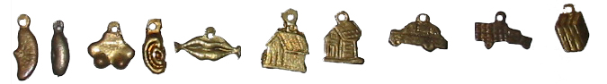
Pictures from: http://www.zanzibartrading.com/MexicanMilagros.htm
Information about Milagros from: A Kid’s Guide to Latino History by Valerie Petrillo

