PEER EDITING
Today you will be peer editing each other’s presentation, making corrections and marking on the rubric on the other side to give feedback. PLEASE REALLY BE HONEST AND PAY ATTENTION TO ERRORS! This will help your fellow classmates! This is just to help you….your classmates may not see all errors…so be sure you go back through your paper as a group and see if all components are met on the RUBRIC!
Step 1: Pass your paper to the group to your right.
Read the rough draft. Focus on Contents. As you read it, check off on the rubric that they have included details about WHERE, WHEN, HOW the disaster AND the accident happened. Also, WHO was hurt, WHO intervened (hero/heroine). Also that they have included at least one interview of a witness.
Circle one of the 4 categories for CONTENTS you think best fits.
Write on paper: 1 thing the group did very well in regards to content. 1 thing you think they need to improve, make more clear, include, etc.

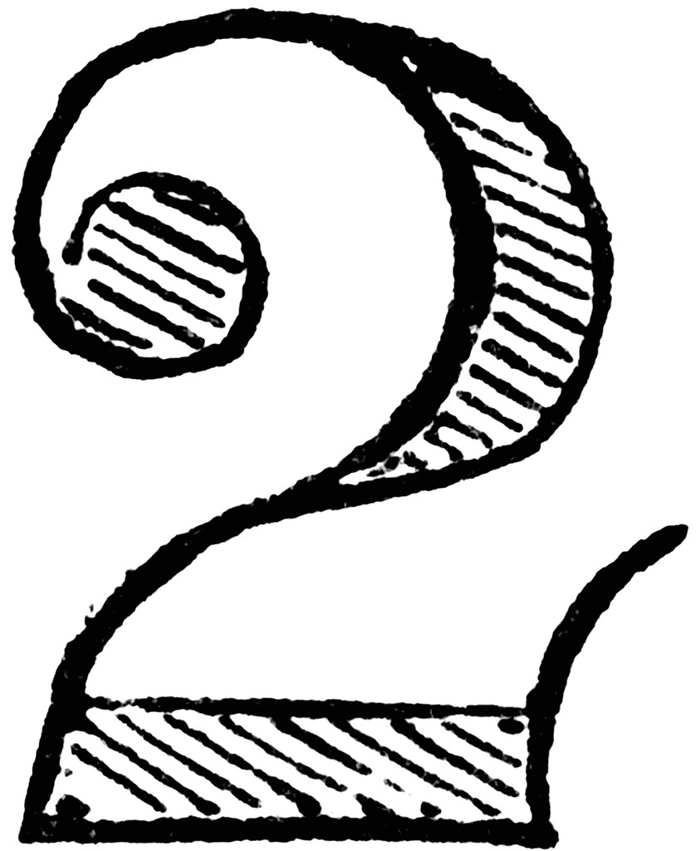
Step 2: Pass your paper to the group to your right.
Read the rough draft. Focus on Details and Vocabulary AND Comprehensibility. Mark any errors you see. Does the group include wonderful details?
Does the group use rich and relevant level 3 vocabulary, ie Chapter 5A and 5B vocabulary?
Do they use the level 3 and new vocabulary correctly?
Circle one of the 4 categories you think best fits on the rubric for DETAILS/VOCABULARY and COMPREHENSIBILITY
Write on paper: 1 thing the group did very well, 1 thing that the group can do to improve the presentation.

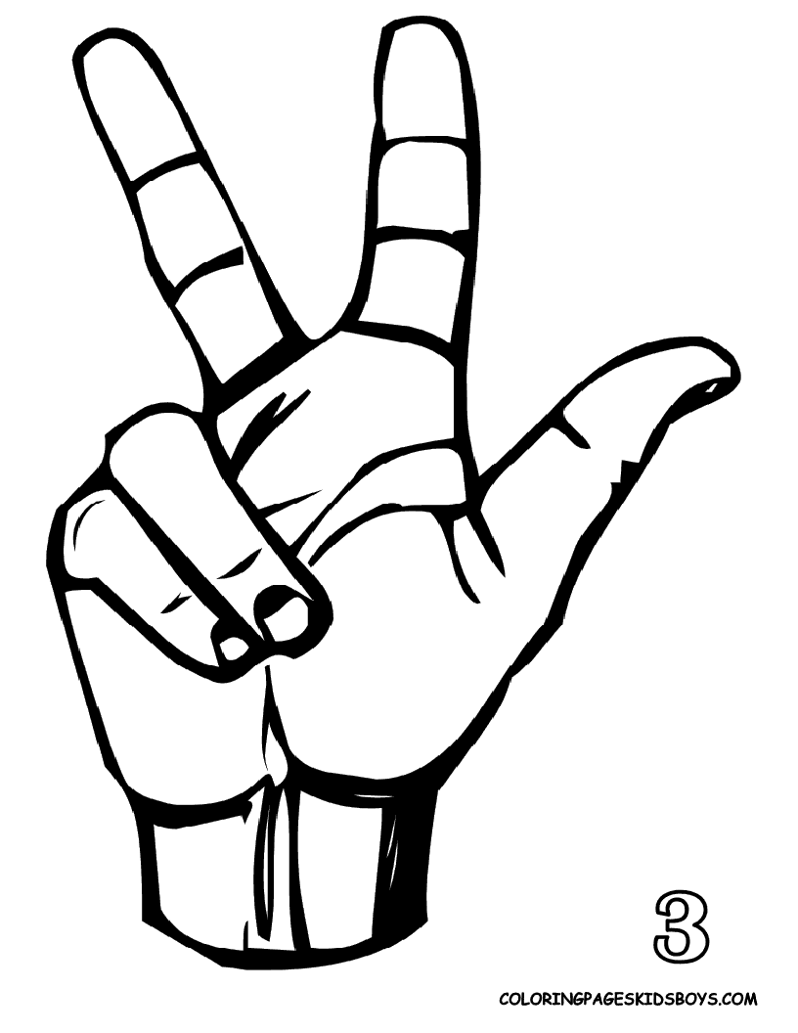
Step 3: Pass your paper to the group to your right.
Read the rough draft. Focus on Grammar. Mark any errors you see.
Does the group correctly conjugate all verbs correctly (preterite, imperfect, present, present perfect)
Does the group correctly use the preterite and imperfect? (look at your folder to remember uses)
Does the group make adjectives agree in number in gender and spell correctly?
Circle one of the categories for PRETERITE AND IMPERFECT and OTHER GRAMMAR on rubric.

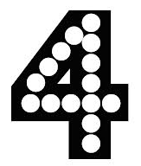
Step 4: Pass your paper to the group to your right.
THIS IS A REPEAT OF STEP 3….always good to double check! Read the rough draft and double-check to be sure that the group before you didn’t miss something related to grammar. This is super important (30% of grade). Mark any errors you see.
Answer the same questions as above for Step 3 and then Circle one of one of the categories for PRETERITE AND IMPERFECT and OTHER GRAMMAR on rubric. It is okay if it isn’t the same grade previous group gave.
Step 5: Return the paper to the original group.
With the group next to you do the following:
Group A: Have one person in group take out their phone to serve as a timer. Begin the timer and have Group A read their script. While listening, mark on the rubric the category that best fits for the LENGTH & SHARED RESPONSIBILITY and PRONUNCIATION & FLUENCY. Verbally give them any feedback about their length, shared responsibility, pronunciation and fluency.
Group B: Have your group members read their parts of the script while Group A times your group and listens for good pronunciation, fluency, and that you have shared speaking responsibility. They will also time you to see you have met the minimum requirement.
REMEMBER: For your video you MUST have YOUR LINES MEMORIZED!!
NOW switch roles! Group A reads script while Group B times and grades.
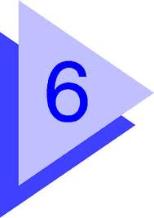
Step 6: Look over your rubric and your script
Make any necessary corrections/revisions. Start memorizing your lines! NO NOTES on video. Make arrangements to record your video: before school, after school, weekend, etc.
Proyecto Final del Pretérito y el Imperfecto Evaluation for ____________________________________________ per __________

Length & Shared

responsibility _______

10 meets minimum time length and speaking parts are shared equally
5 meets time minimum, but too much “dead air” or filler time and/or speaking parts not shared equally
- did not meet minimum length and/or speaking parts not share equally

Details/Vocabulary _______

20 wonderful details, rich & relevant level 3 vocabulary and new words
15 some good level 3 vocabulary and new words, used correctly
10 adequate, some vocab misused, very little level 3 vocab nor new words
5 need more details, skimpy vocabulary

Contents _______

20 includes footage and details about where, when, how disaster & accident happened, who was hurt, who intervened (hero/heroine) and at least one interview of a witness
15 lacking one or a few components
10 lacking half the components
5 most components are missing

Comprehensibility _______

10 100% comprehensible
8 mostly comprehensible
6 the gist is communicated, but parts are confusing
4 A native speaker might have problems understanding you because:

Comments:
Preterite and Imperfect _______

20 shows command of forms and uses
14 shows good knowledge of forms and uses, with occasional errors of a minor nature
8 shows only basic knowledge with occasional significant errors
5 shows shaky knowledge of u ses and forms, with frequent significant errors.
0 incorrect forms outnumber correct ones

Other grammar _______

10 no mistakes, or mistakes weren’t distracting
7 a few mistakes but meaning was clear
3 mistakes were distracting
0 what’s grammar?

Pronunciation & Fluency _______

10 great accent and pronounced all words correctly with smooth, natural speech
8 a couple of words mispronounced, accent could use work, mostly smooth, consistent
6 several words mispronounced, accent distracting, some pauses but still acceptable
4 ¡ay, ay, ay! too choppy

EXTRA EFFORT + _________

TOTAL __________

A readable, length appropriate roughdraft turned in April 30th?

YES

NO -10 pts

